Spatial Temporal Patterns: A look into Airbnb Distribution in Seattle, Washington

Luis Flores, Pranav Kartha, Wesley So

**Abstract**

With the rise of convenient homes close to hot spot tourist locations, Airbnbs have become a popular way of finding cheap areas to live while on the go. In this paper, we ask the question, is the growing presence of Airbnb listings correlated with housing shortages in neighborhoods of Seattle?Previous research has shown that Airbnb has imposed different impacts based on locations through comparing the Airbnb distributions of different cities (CITE). While this is good starting information it only tells readers that different cities have different distributions of Airbnb based on where their popular locations are. This information does not provide how Airbnb has influenced cities over a period of time. In our research we used publicly available Airbnb and Census data from 2015 to 2018 along with 3 metrics to evaluate the patterns that have emerged over time in the city of Seattle. Our findings have shown a positive correlation between Airbnb densities and rental/vacant households over time in the Seattle area. This is significant as it shows that there are signs of Airbnb being a factor to a growing number of vacant houses that could be used for housing of others but is instead used as Airbnb that may not even be used.

**Introduction**

Over the last few years the sharing economy has become increasingly popular. (Zervas, Proserpio, and Byers, 2017). Companies such as Netflix and Zipcar are now mainstays in their respective markets only a decade after launching (Botsman and Rogers, 2010). This in large part has been enabled by the advent of the internet and rapidly developing technology (Zervas, Proserpio, and Byers, 2017). The sharing economy has allowed companies such as Airbnb to bring solutions to people's problems. According to Botsman and Rogers, millions of houses are empty therefore companies like Airbnb create a marketplace that allows private owners and commercial properties to rent out the space (2010). This means anyone looking to earn extra income from an empty living space can easily go on a website and list the property. Furthermore, this can be done for a huge number of places across the globe. Airbnb states that there are more than 100 thousand cities worldwide with listings (Airbnb).

In this paper we focus on the impact the sharing economy has had on the housing share of an urban city. Specifically, we focus on the relationship between Airbnb listings and neighborhood housing shortages in Seattle, Washington. In order to understand this relationship we use census tracts for the city of Seattle and find the number of listings within each. In order to get a more nuanced understanding we create three metrics that involve homes, vacancy rates and the number of rentals in the city of Seattle. This is done for three different years in order to understand the spatial temporal patterns that emerge over time.

**Data Sources**

For this research we collected data from a few different sources. These sources included Inside Airbnb, Census Tracts from the City of Seattle, and data from the American Community Survey from the United States Census Bureau.

Inside Airbnb was used to collect listings for Airbnbs in the city of Seattle. It is important to note that the data used was for a specific date and not the whole year. This means that the listings were a snapshot in time, and not representative of the whole year. Our research tried to keep the dates within the summer season, however data for the summer of 2016 was not available so we used winter data for that year. For 2015, we used data collected on June 22. For 2016, data was collected on January 4, and for 2018, data was collected for August 16.

Census tracts were obtained from the city of Seattle through the GeoData portal. 2010 Census Tracts shapefiles were obtained. American Community Survey data was obtained from the US Census Bureau Data Portal, table DP04, was accessed and we filtered it by census tracts.

**Methodology**

In order to determine the relationship between Airbnb and neighborhoods in Seattle we first cleaned up the listings gathered from the Inside Airbnb website. We removed information that was deemed not useful for this project such as ratings, number of days since the last rating, the name of the person listing the home as well the number of listings per person. We also had to remove the large number of single rooms in the data. While Airbnb does have listings for single rooms in apartments/homes we do not want to look at these listings as they do not take away housing from a person. We want to focus specifically on listings where the entirety of homes are being used, as these can be indicators of housing being taken away. After this we made sure the data was joinable in ArcMap by ensuring that our fields were of the right type.

We then moved to ensure data from the table of 2018 5 Year Estimates DP04 Selected Housing Characteristics from the American Community Survey was ready to use. We had to make sure we obtained the number of homes, the number of vacancies and the number of rentals and removed the rest of the information that did not include these numbers. Since TIGER/Line shapefiles have a ten digit GEOID field that allows you to join the files, we had to ensure that the DP04 table had the ten digit GEOID field in order to join the tables..

After all the data was gathered and checked we proceeded to use ArcMap to import the census tracts for Seattle. We then imported the listings. These listings were displayed using XY (longitude and latitude) coordinates. Once we had both these files we then performed a Spatial Join that counted the number of points (listings) in each polygon (census tract). This then gave us a field that counted the number of listings per each census tract. This value was important as it would be the denominator in our indices.

After we performed the Spatial Join, we joined this table containing the number of listings per census tract with the table DP04 based on the GEOID. After this join we then created three fields each one for a different metric in our index. The three metrics are as follows:

$AirBnB Prevalence Housing Metric = \frac{Σ Apartment/Homes Listed on AirBnB }{Σ Homes in a given census tract}$

$AirBnB Prevalence Rental Metric = \frac{Σ Apartment/Homes Listed on AirBnB }{Σ Rentals in a given census tract}$

$AirBnB Prevalence Vacancy Metric = \frac{Σ Apartment/Homes Listed on AirBnB }{Σ Number of Vacancies in a given census tract}$

This same process was done for each of the three years we looked at. After the indices were created we mapped our results.

**Findings**

There appears to be a general trend of all four indices being highest in central areas of Seattle. As one travels farther away from central regions of the city, in general, the rankings for the observed indices decreases. This trend appears to be the most pronounced when looking at the total number of listings and number of listings per home, with both of these metrics showing a strong contrast between central and outer regions of Seattle. The trend still exists for the other variables measured(listings per number of rental homes and listings per number of vacant homes) overall show the same trend, but with more variation; with some higher rankings in census tracts farther away from the center of Seattle.

In general, the overall trends remained the same across the three years we chose to observe, however, in later years, there appear to be a much greater number of Airbnb listings in Seattle, resulting in inflated values for the observed metrics.

**Conclusion**

Over the past couple of years, AirBnb’s presence in Seattle has increased dramatically, especially in areas in the central area of the city. This is correlated with higher numbers of vacancies, listings per number of homes, and listings per number of rental homes, implying a correlation between the presence of AirBnb and housing shortages in the Seattle area. An explanation for this trend could be that, due to the growing popularity of Airbnb, more people who own property in downtown Seattle are using Airbnb to rent their property to tourists rather than selling their apartments. Since housing prices in Seattle have been steadily increasing in recent years, people who own property have the incentive to keep the property they have, in hopes that they can get more money out of their property. Airbnb provides homeowners with the opportunity to make money off their unused property by using their service, and thus disincentivizes selling their property. In this way, Airbnb contributes to the housing shortage in Seattle, as it can use it to make a profit. Since there has been an overall increase in vacancies and housing shortages in the time period, it would not be a stretch to assume that in the future, the amount of vacancies caused as a result of Airbnb will only increase as time goes on.

**Maps**

*Figure 1 Listings per Tract 2015*

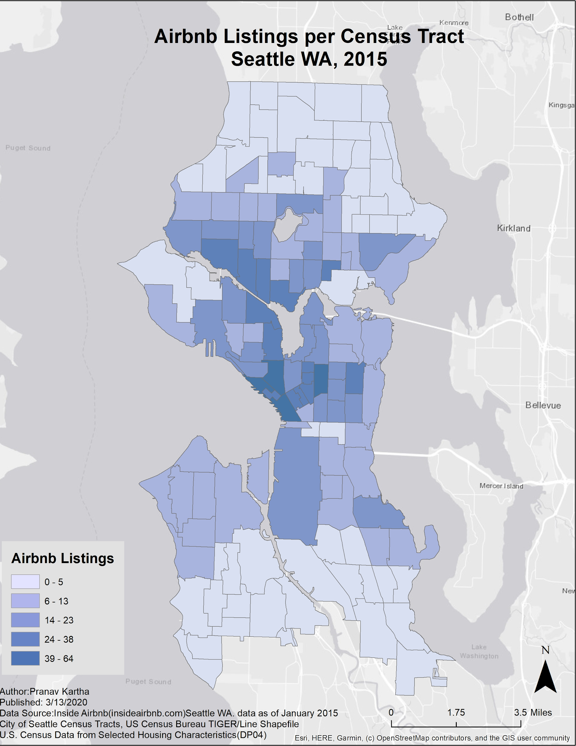

*Figure 2 Listings per Tract 2016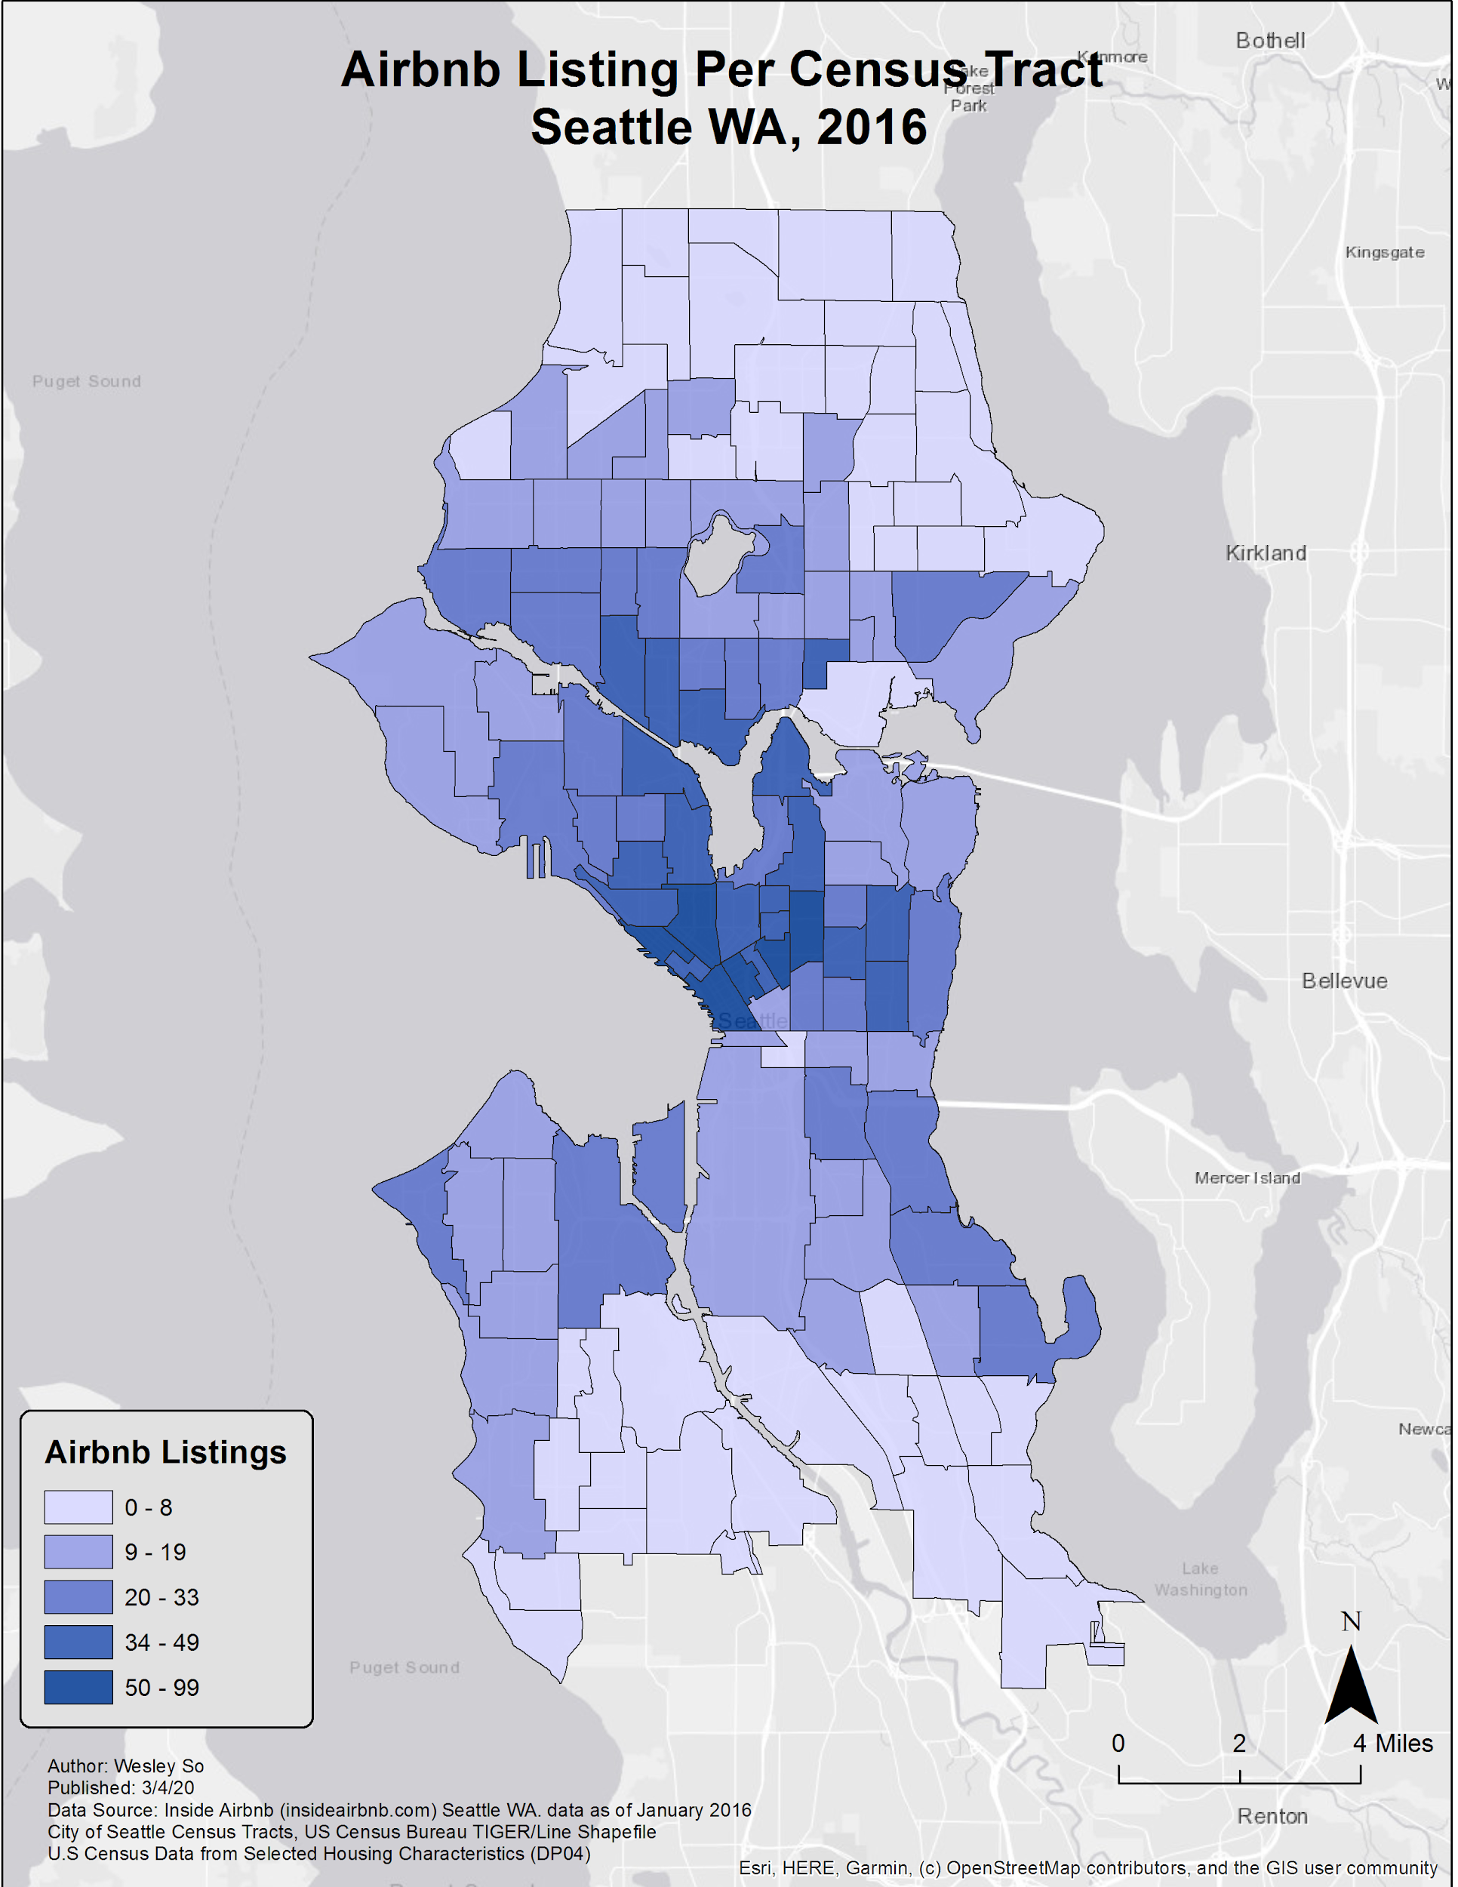Figure 1 Figure 3 Listings per Tract 2018*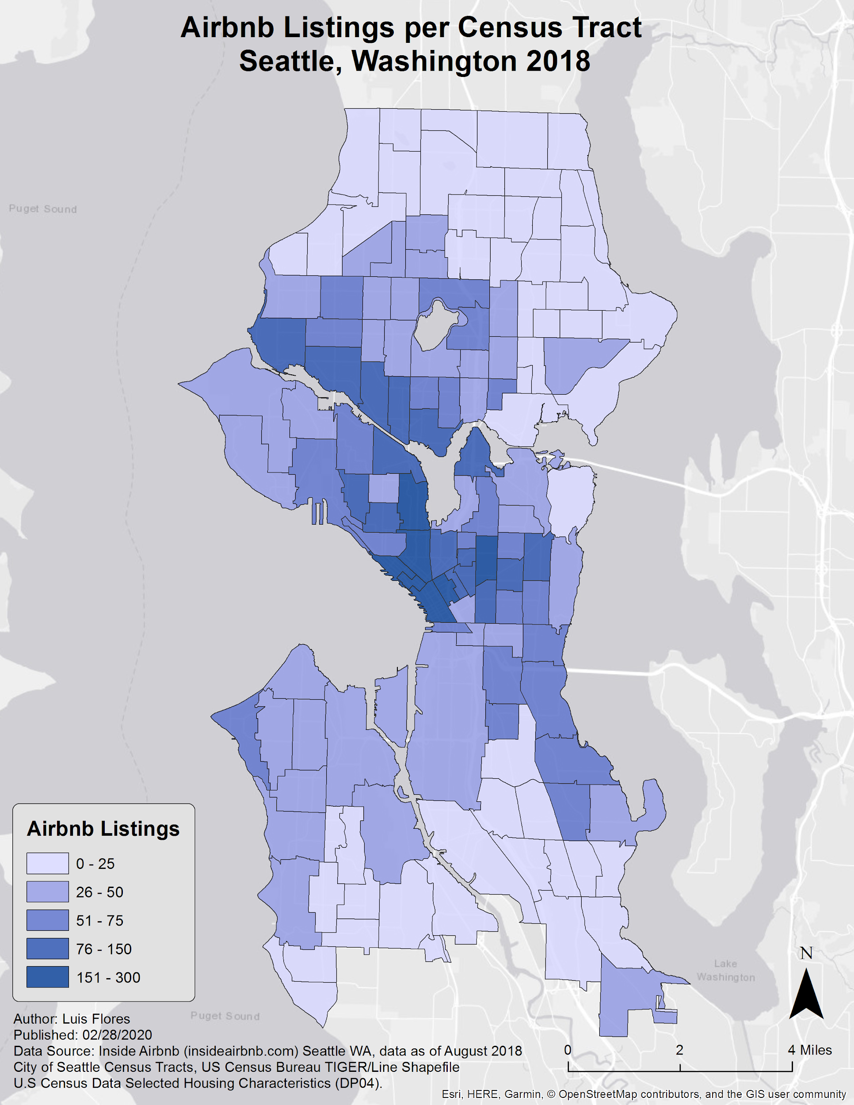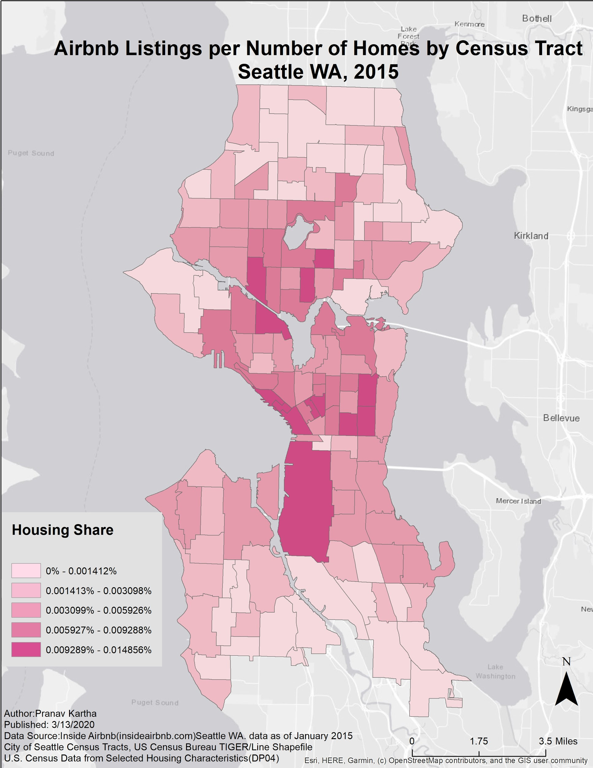

*Figure 4 Airbnb Listings per number of homes 2016*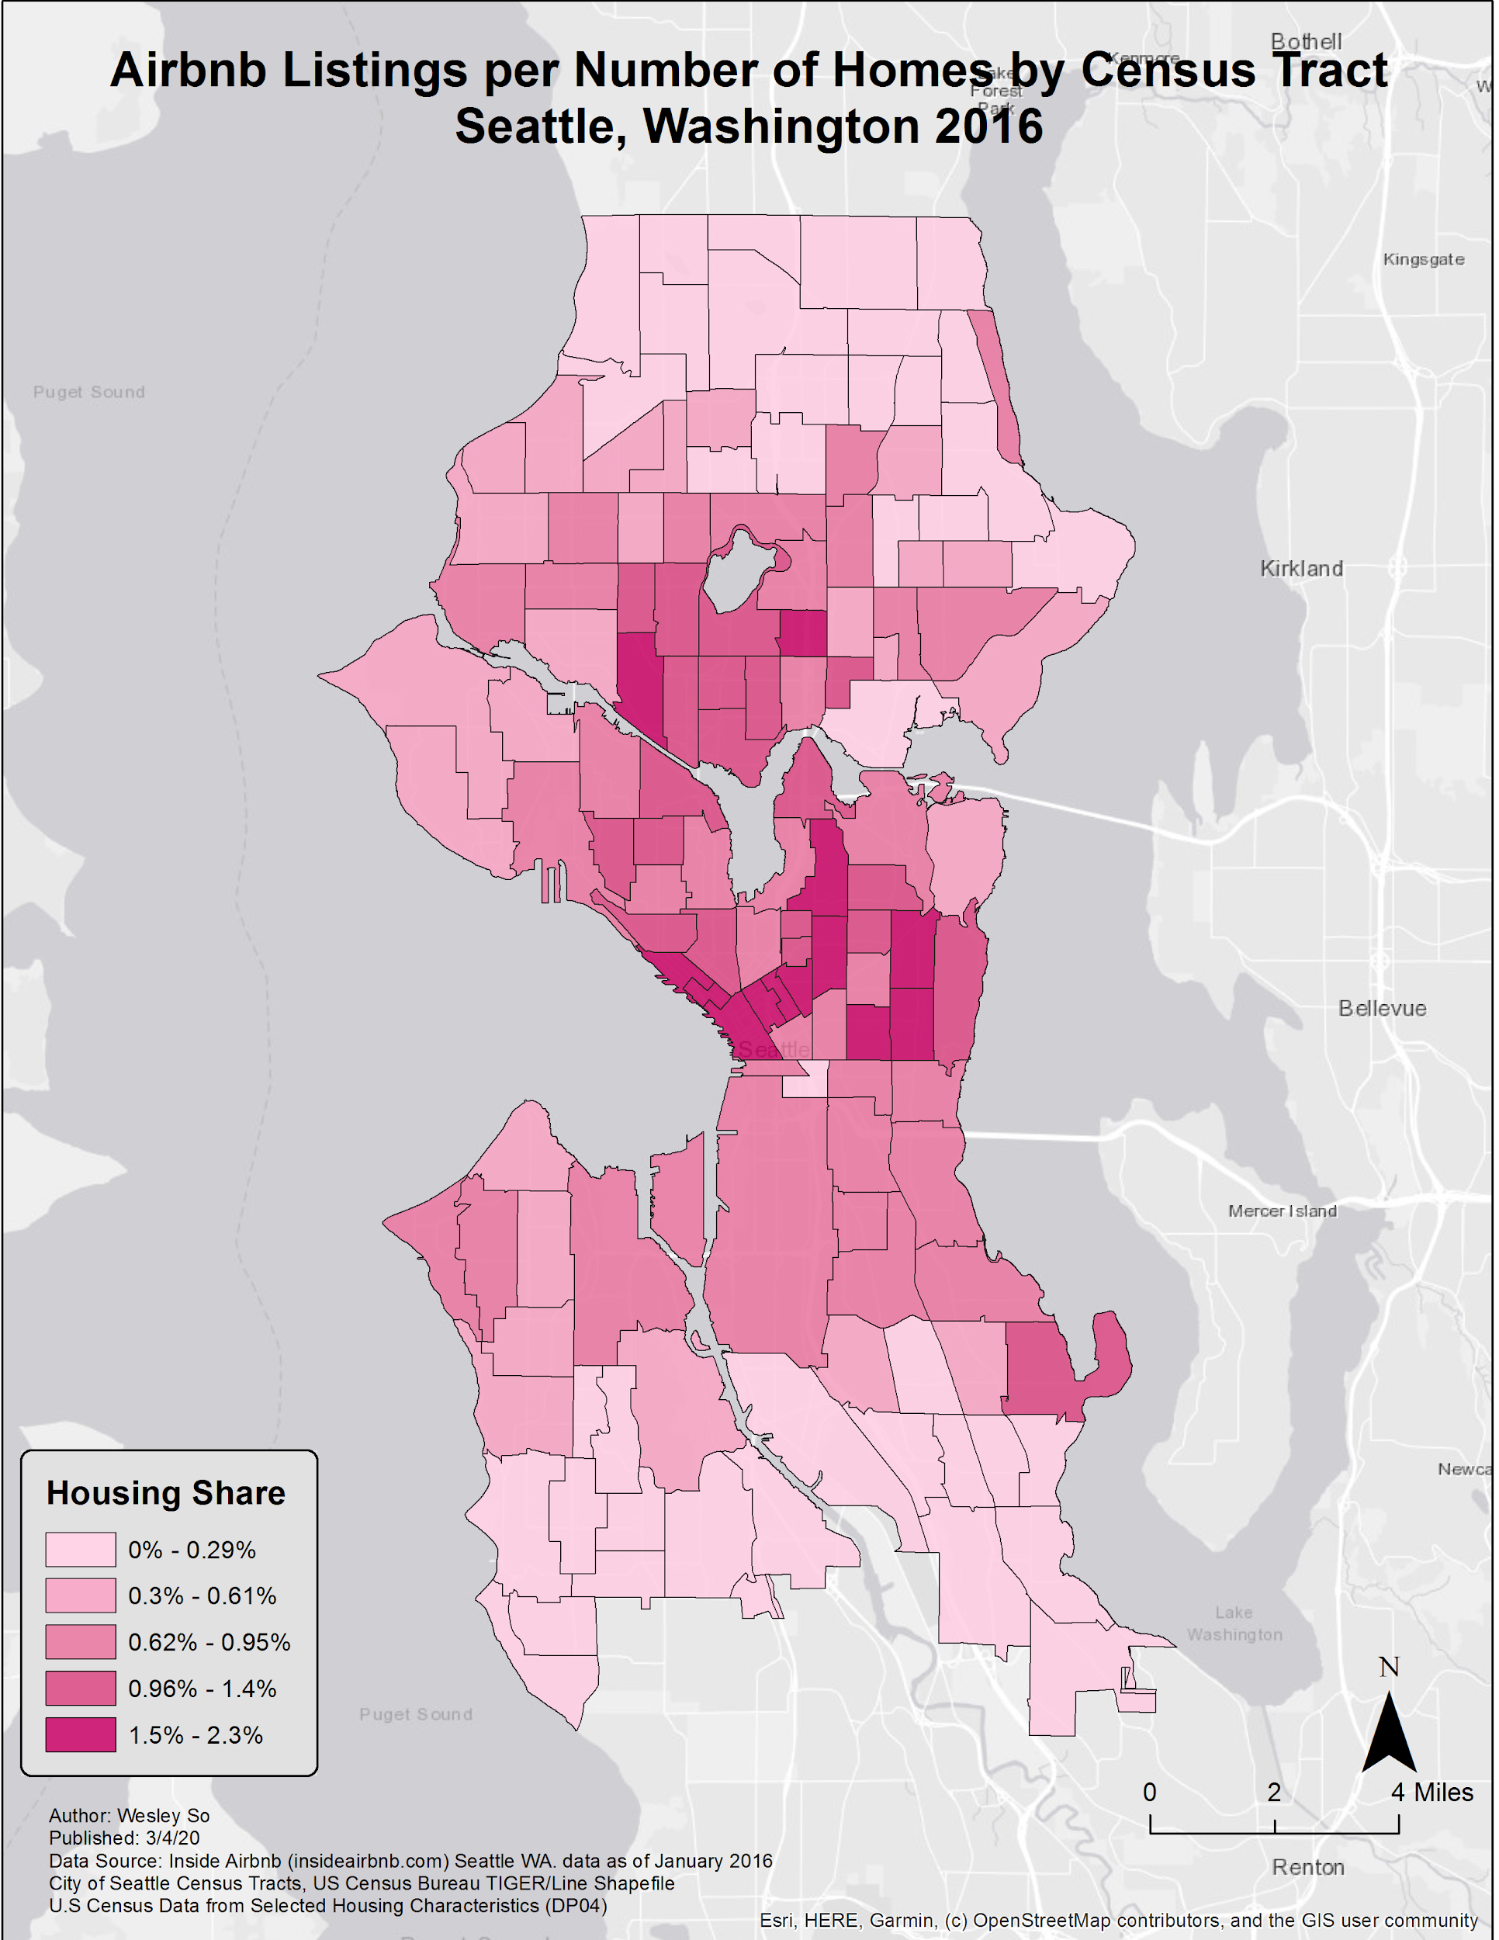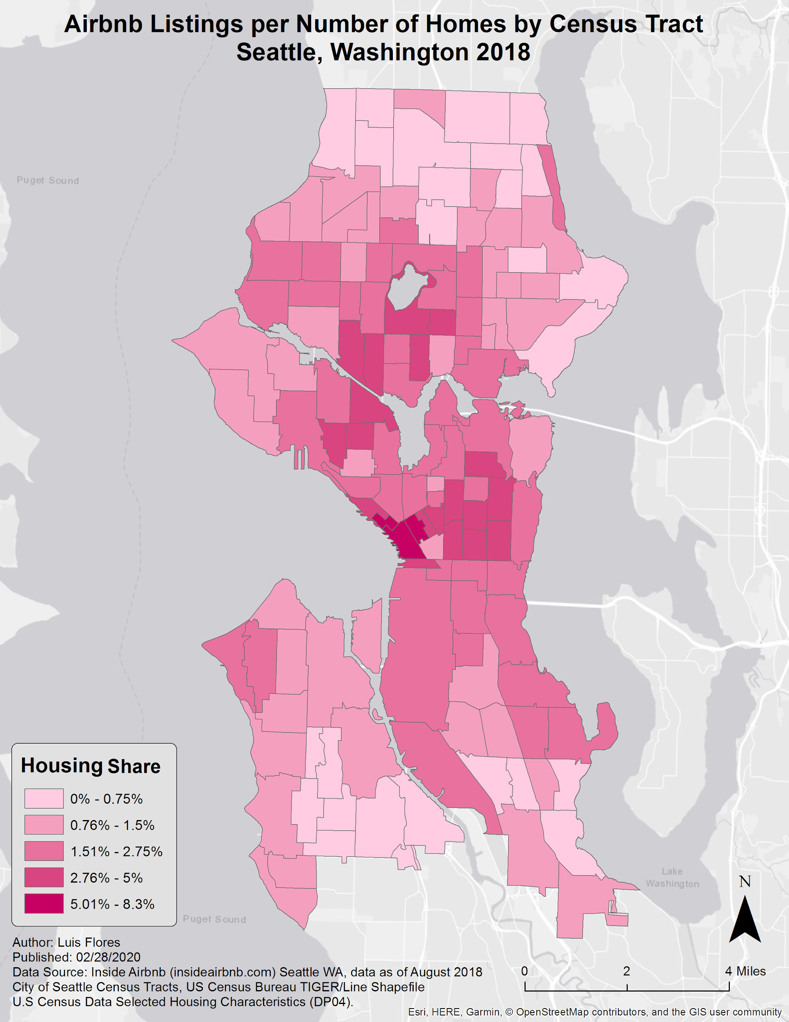

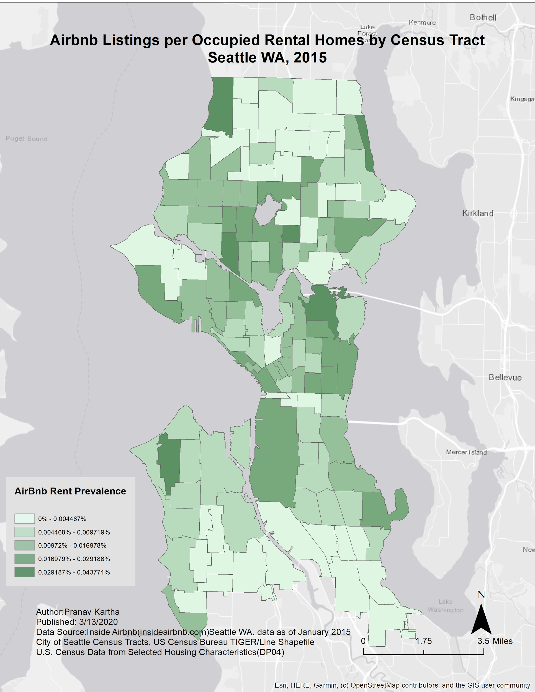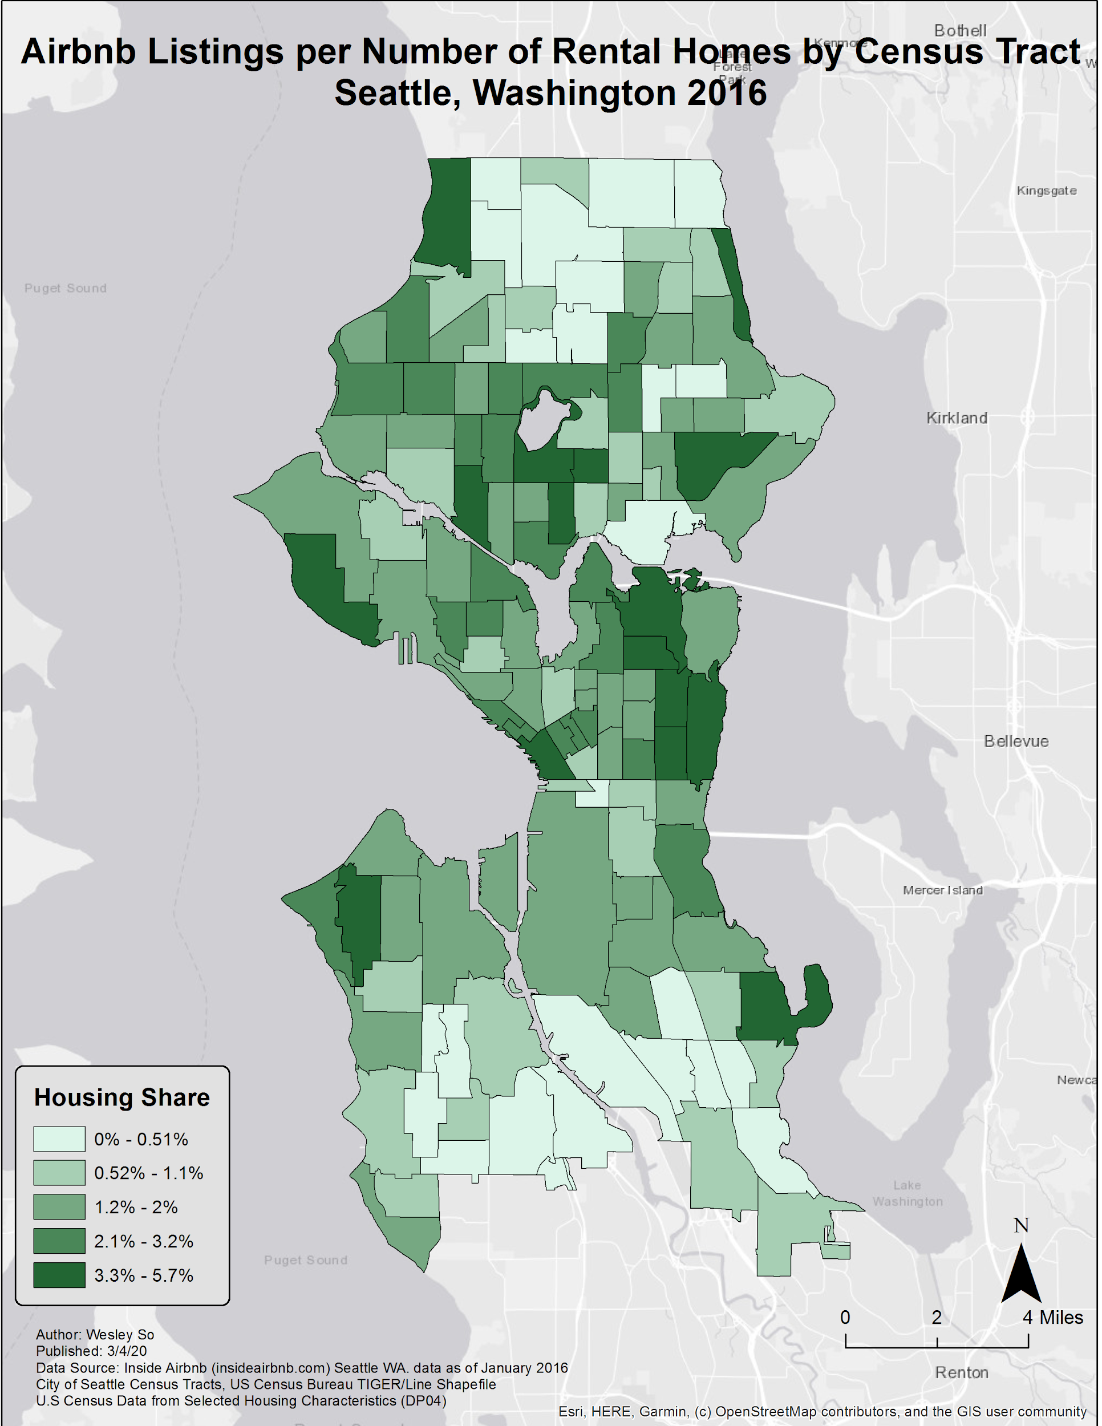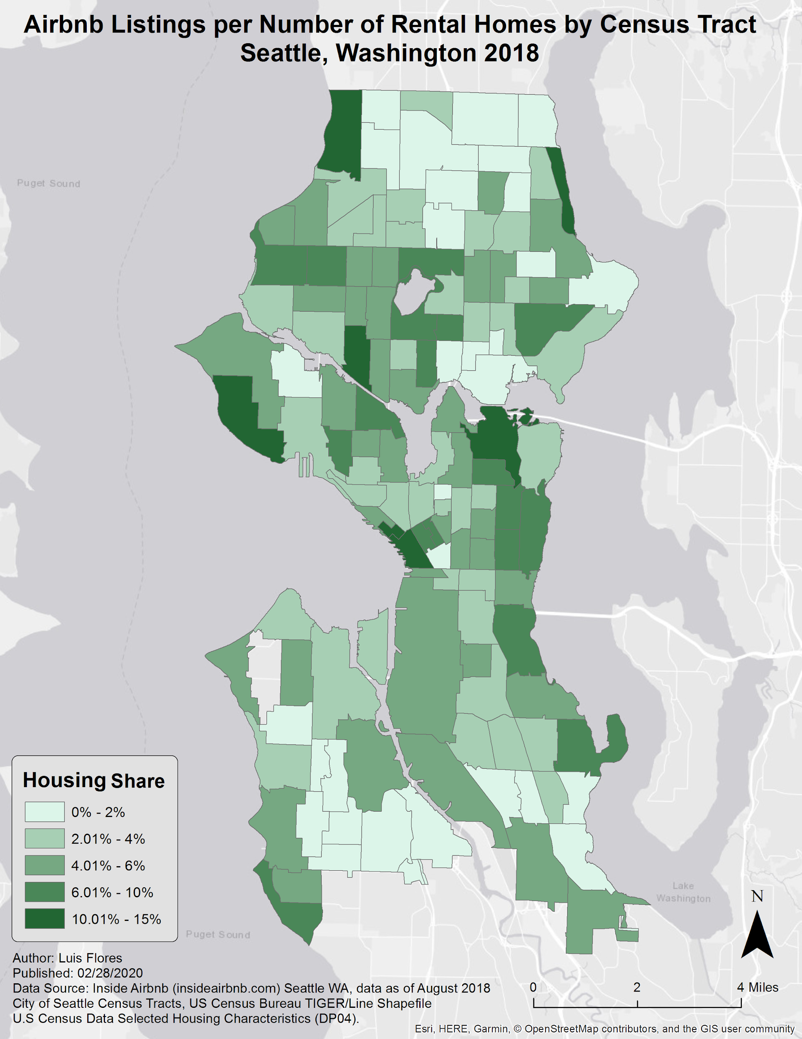

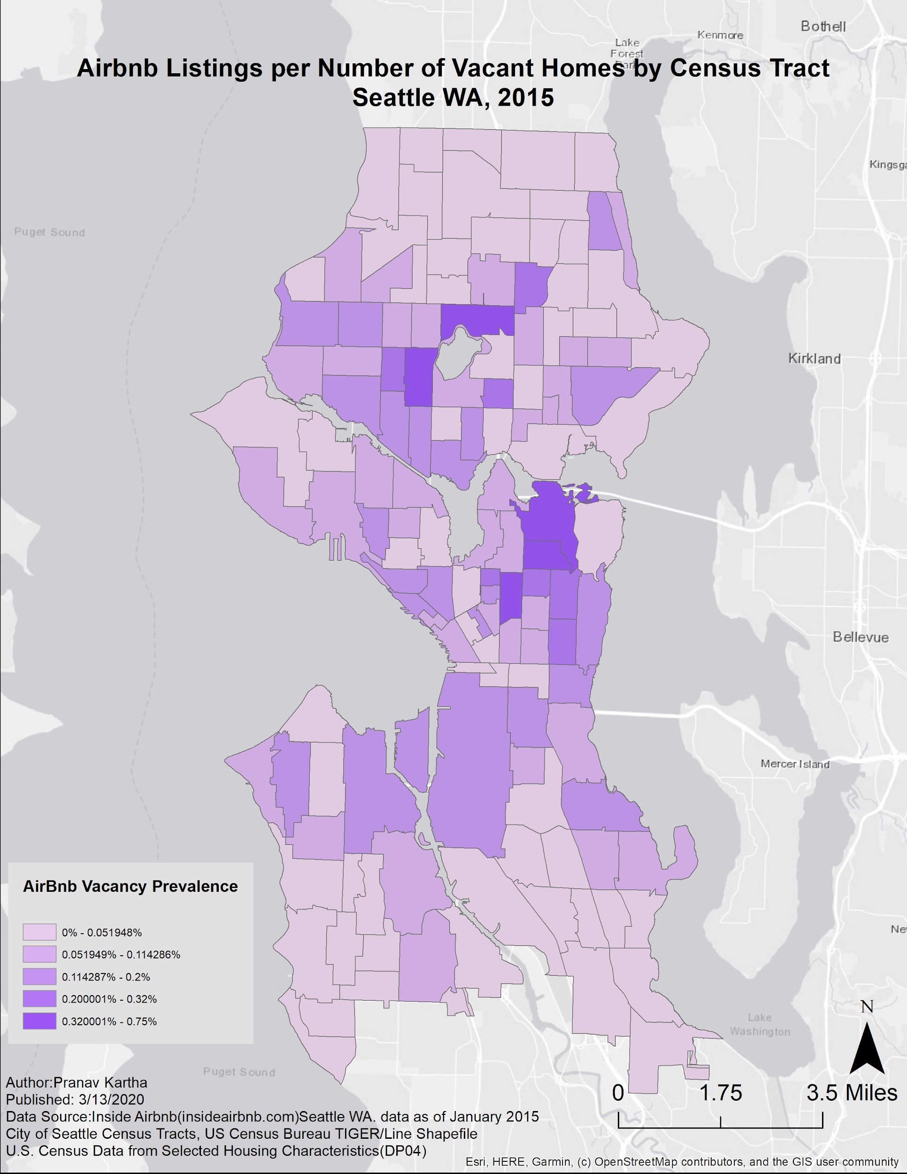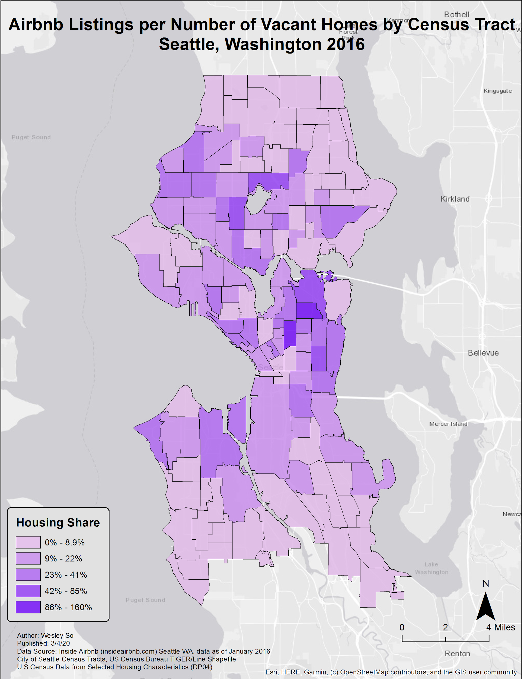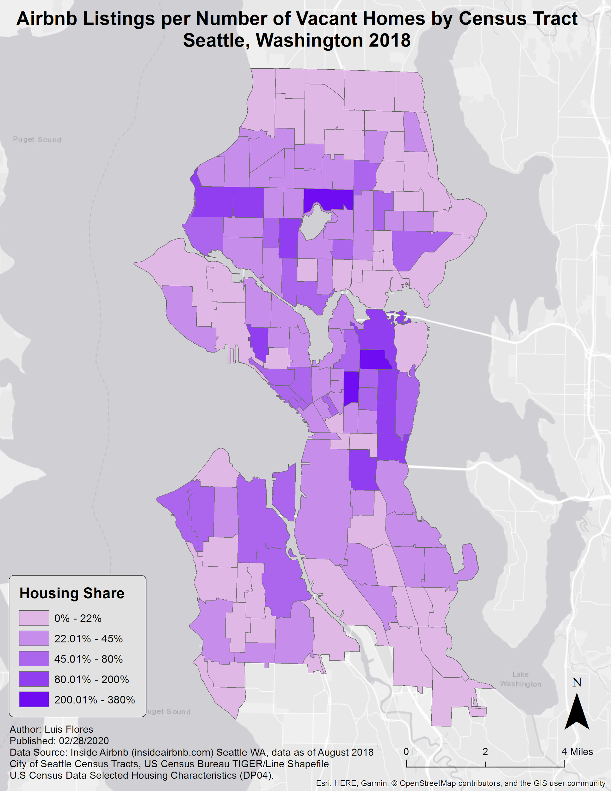

**Geographic Data Sources**

|  |  |  |  |  |
| --- | --- | --- | --- | --- |
|  |  |  |  |  |
|  |  |  |  |  |
|  |  |  |  |  |
|  |  |  |  |  |
|  |  |  |  |  |
|  |  |  |  |  |
|  |  |  |  |  |

**References**

Jiao, J., & Bai, S. (2019). Cities reshaped by Airbnb: A case study in New York City, Chicago, and Los Angeles. *Environment and Planning A: Economy and Space*, *52*(1), 10–13. doi: 10.1177/0308518x19853275

Sarkar, A., Koohikamali, M., & Pick, J. B. (2017). Spatiotemporal Patterns And Socioeconomic Dimensions Of Shared Accommodations: The Case Of Airbnb In Los Angeles, California. *ISPRS Annals of Photogrammetry, Remote Sensing and Spatial Information Sciences*, *IV-4/W2*, 107–114. doi: 10.5194/isprs-annals-iv-4-w2-107-2017

Wachsmuth, D., & Weisler, A. (2018). Airbnb and the rent gap: Gentrification through the sharing economy. *Environment and Planning A: Economy and Space*, *50*(6), 1147–1170. doi: 10.1177/0308518x18778038